PROJECT REPORT
Project Title: LAPTOP REQUEST CATALOG ITEM
Duration: 15 Days
Name: Tharunis T K
ABSTRACT:
The Laptop Request Catalog Item project focuses on automating and streamlining the laptop request process within an organization using the ServiceNow platform. Previously, the procedure was manual, time-consuming, and lacked real-time tracking. The proposed system introduces an interactive catalog form that enables employees to easily request laptops and accessories. The form dynamically displays relevant fields based on user selections and automatically assigns each submission a unique Request ID. This automation improves efficiency, minimizes approval delays, and strengthens IT asset management through accurate data collection and visibility.

PROBLEM STATEMENT:
In many organizations, employees face challenges in requesting laptops due to a manual, paper-based process that often results in incomplete details, data errors, and approval delays. Moreover, there is no centralized system for tracking the status of requests. To overcome these issues, a ServiceNow-based automated catalog item is required — one that provides a user-friendly interface, ensures data accuracy, automates workflow approvals, and enhances request traceability.

OBJECTIVES:
- To create a dynamic and automated Service Catalog item for laptop requests.
- To configure UI Policies that manage field visibility and behavior based on user input.
- To design a UI Action for resetting or clearing the form fields.
- To ensure unique Request ID generation for each submission.
- To export configurations using Update Sets for deployment in other instances.
- To test and validate all functionalities through sample submissions.

METHODOLOGY:
- Requirement Analysis:
Studied the existing laptop request process and identified key fields such as laptop model, justification, quantity, and accessories.
- Catalog Item Development:
Created a Service Catalog item titled “Laptop Request” using ServiceNow’s Catalog Builder tool.
- UI Policy Configuration:
Designed dynamic rules that display or hide additional fields when the user opts for accessories.
- UI Action Implementation:
Developed a “Reset Form” button to clear all user inputs and restore default settings.
- Workflow Integration:
Linked the catalog form to ServiceNow’s request management system for automatic request number creation and tracking.
- Update Set Management:
Saved and exported all configurations into an Update Set for migration across different ServiceNow instances.
- Testing and Validation:
Conducted multiple test submissions to ensure accurate data entry, workflow completion, and correct Request Number generation.

MODULES INVOLVED:
- Service Catalog Item:
  - Serves as the main interface for users to submit laptop requests.
  - Includes fields such as Laptop Model, Justification, Quantity, and Accessories.
- UI Policy:
  - Controls visibility and behavior of fields dynamically.
  - Improves accuracy and user experience.

- UI Action:
  - Provides an option to reset or clear all entered data.
  - Enhances usability and convenience.
- Export Update Set:
  - Stores all configuration changes for reuse and deployment in other instances.
- Login to Another Instance:
  - Used for testing and verifying that the update set imports successfully and maintains compatibility.
- Testing:
  - Verified that requests are generated properly.
  - Confirmed accurate workflow execution and delivery tracking.

RESULT:
The Laptop Request Catalog Item project successfully automated the laptop procurement process using ServiceNow. The form dynamically adapts to user inputs, ensuring accuracy and completeness. Each request generates a unique tracking ID, and users receive confirmation upon submission. The new system provides full visibility of request status, approval progress, and delivery details. As a result, IT operations have become more efficient, eliminating manual paperwork and reducing request turnaround time.

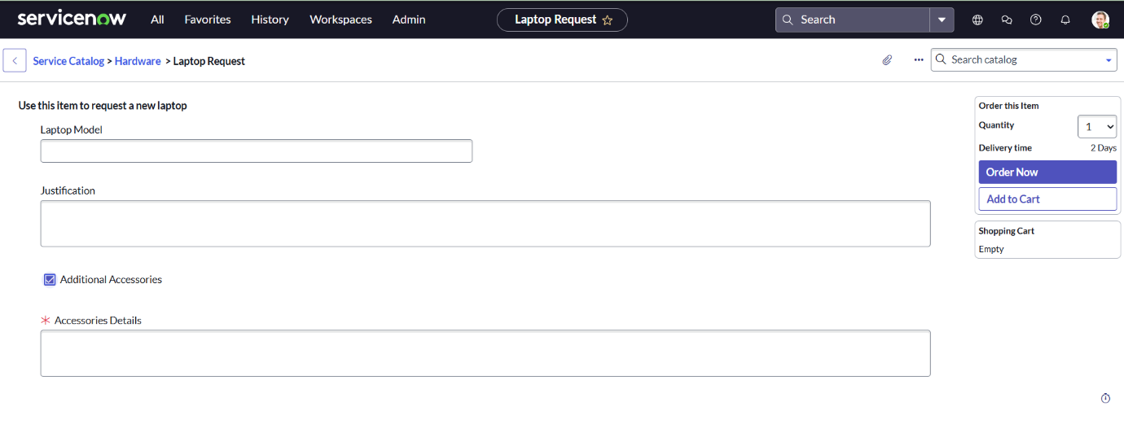

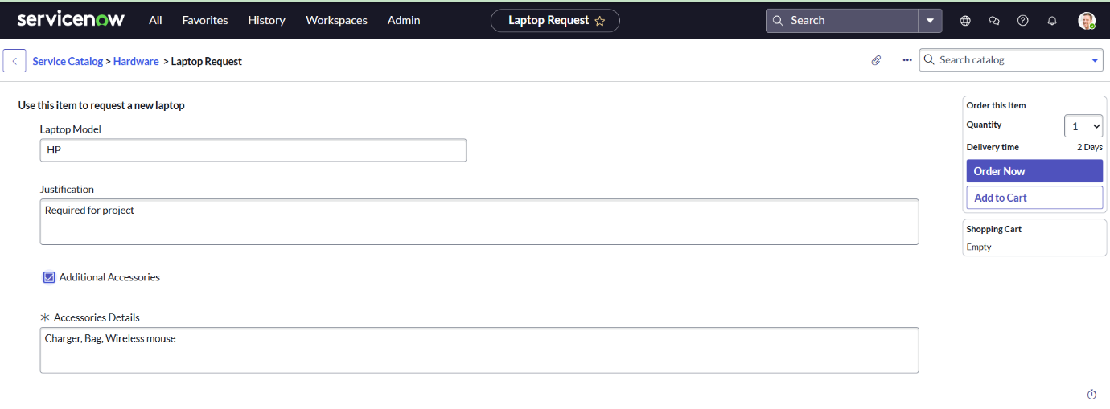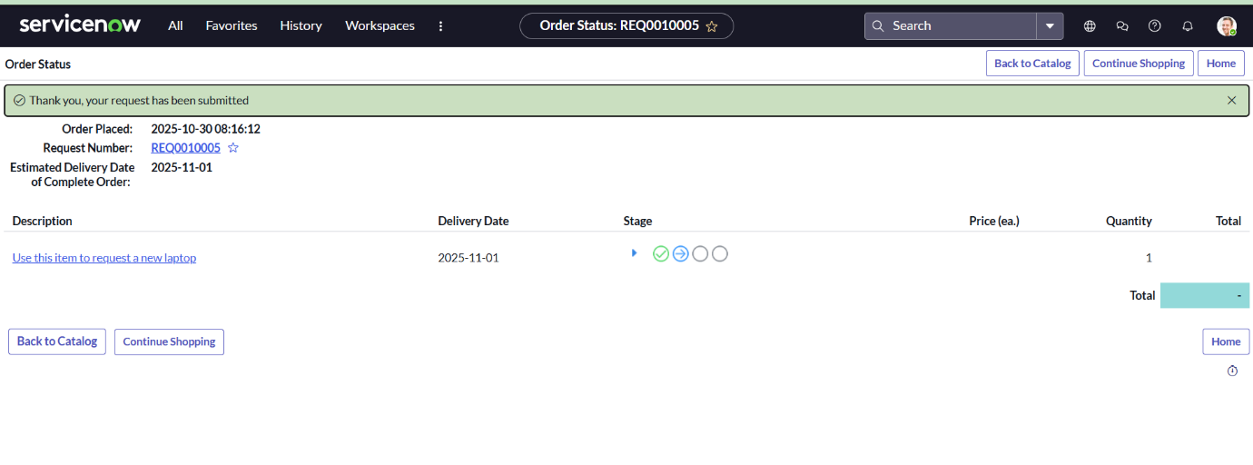

CONCLUSION:
The Laptop Request CatalogItem project achieved its primary goal of simplifying and automating laptop requests. Utilizing ServiceNow’s Catalog Builder, UI Policies, and UI Actions, the project delivered a fully functional, interactive, and automated catalog system. The form’s dynamic nature enhances usability, while automated workflows ensure reliable tracking and governance. Overall, this project improves service efficiency and supports better IT resource management.

FUTURE ENHANCEMENTS:
- Integrate with the Asset Management module for automatic inventory updates.
- Enable email notifications for request approval and delivery updates.
- Implement a multi-level approval hierarchy (Manager → IT Admin).
- Create an analytics dashboard to visualize request and approval statistics.
- Extend the catalog system to include other IT assets such as monitors, printers, and accessories.

REFERENCES:
- ServiceNow Product Documentation — https://docs.servicenow.com
- ServiceNow Developer Portal — https://developer.servicenow.com
- IT Service Management Fundamentals — ServiceNow Training Resources
- Internal Project Guidelines — ITUP Kid Hub

